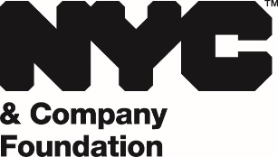

2022 BOROUGH CULTURE GRANT PROGRAM COVER SHEET AND PROPOSAL REQUIREMENTS: QUEENS

Borough: QUEENS Date Submitted: ____________________

Organization and Project Title: _________________________________________________

_________________________________________________

Project Manager Name and Title: _______________________________________________________

Telephone: ________________________ E-mail: ____________________________

Below are the items that are required before any request for a grant from the Borough Culture Grant Program will be considered:

______ Amount of the grant being requested.

______ Detailed description of the project being funded including its cultural programming objectives.

______ Complete line item budget of the project, including a description of the line items to which grant funding would be applied.

______ Detailed project or program marketing plan indicating how the project will be promoted to the public, including proposed vendors and outlets.

______ Detailed project timeline indicating all significant milestones/phases.

______ Detailed description of how project outcomes will be measured.

______ Copy of the recipient organization’s 501(c)3 certification.

______ Authorized Signature

SUBMISSION DEADLINE: January 24, 2022
Proposals submitted after January 24, 2022 cannot be considered for funding in this grant cycle.
PBallman@QueensBP.org

